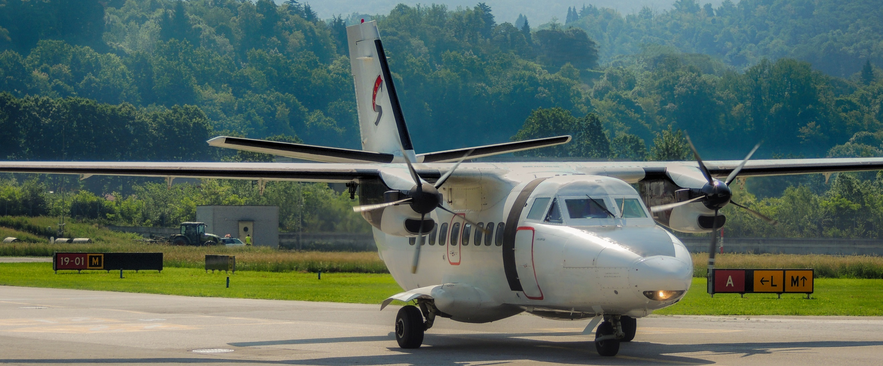
Direct flights to Lošinj

Lošinj has never been closer to our guests and can be reached quickly by plane. Lošinj Hotels & Villas announces new scheduled flights in the period from 24.06. till 16.09.2018. Daily flights from Zagreb, Pula, Split or Lugano to Lošinj at a price from 235 EUR (return ticket).

With this service we also offer transportation from the airport to the hotel or villa, and on departure transportation to the airport.

No matter when you choose to visit Lošinj, with your first step on the island, you will be able to inhale fragrances of more than 1000 aromatic and healing herbs and feel the energy of this very special place. When coming back home, you will feel reborn. Therefore, welcome to Lošinj – island of vitality.

More information and reservations at:

losinj-hotels.com
booking@losinj-hotels.com

info@silverairtravels.com
+41 600 1754

Airplane information:

Weekly timetable from 24.6.2018 to 16.9.2018
from | to | destinations | departure | arrival
 |  | Monday
24.6. | 16.9. | Lošinj - Zagreb | 8:15 | 9:00
24.6. | 16.9. | Zagreb - Lošinj | 14:00 | 14:45
 |  | Tuesday
24.6. | 16.9. | Lošinj - Pula | 11:40 | 12:00
24.6. | 16.9. | Pula - Lošinj | 16:20 | 16:40
24.6. | 16.9. | Lošinj - Split | 17:25 | 18:05
24.6. | 16.9. | Split - Lošinj | 18:40 | 19:20
 |  | Thursday
24.6. | 16.9. | Lošinj - Zagreb | 8:15 | 9:00
24.6. | 16.9. | Zagreb - Lošinj | 14:00 | 14:45
24.6. | 16.9. | Lošinj - Split | 15:20 | 16:00
24.6. | 16.9. | Split - Lošinj | 18:00 | 18:40
 |  | Friday
24.6. | 16.9. | Lošinj - Zagreb | 9:15 | 10:00
24.6. | 16.9. | Zagreb - Lošinj | 14:00 | 14:45
 |  | Saturday
24.6. | 16.9. | Lošinj - Pula | 8:40 | 9:00
24.6. | 16.9. | Pula - Lošinj | 14:30 | 14:50
 |  | Sunday
24.6. | 9.9. | Lugano - Lošinj | 14:50 | 16:30
1.7. | 16.9. | Lošinj - Lugano | 08:00 | 9:40
- AIRPLANE LET410 – UVP – E – operated by Silver Air
- 17 seats

